MANAGE FEELINGS:
As humans, we will experience MANY feelings and sometimes they can feel mixed or jumbled. That’s normal! What is most important is how you handle and manage tough feelings. Instead of letting feelings take over by over-reacting or getting stuck with a negative feeling, try some of the strategies below:

COOL DOWN, WHEN NEEDED:
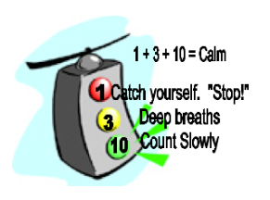
When feelings are so high that you feel like you’re losing control, try a cool-down strategy like the 1-3-10. Other strategies could include: talking to someone, getting exercise, journaling, drawing, getting a hug, taking deep breaths, listening to music, reading something inspirational, and more. Do you know what helps you?

USE POSITIVE SELF-TALK:
The way you talk to others is important. The way you talk to YOURSELF is important, too. Instead of giving yourself a putdown, try positive messages like: “I can do this.” “I’ll do my best.” “Don’t give up.”

PURSUE POSITIVE RELATIONSHIPS:
Just as you should make efforts to build up other people, try to hang with people who build YOU up in a positive way. Although friendships can have some ups and downs at times, a true friend will listen, care, and make efforts to work through challenges together. Surround yourself with people who you like being around and try not to spend all of your energy focusing on others who don’t.

SHOW PATIENCE AND LOVE
(to yourself and others!)
No one is perfect and we all need help at times. Don’t be too hard on yourself when things are feeling tough. Instead, know that it’s okay to ask for help. And when you help others who are in need, that feels good, too!

